UNION results
The stencil for the GETLM used is the union of the exact computational stencils of RK4, CN and AB. Which is
[(-2,-1,0,1), (-8,-7,…,0,1,2,3,4,5), (-2,-1,0,1)]
The results are:
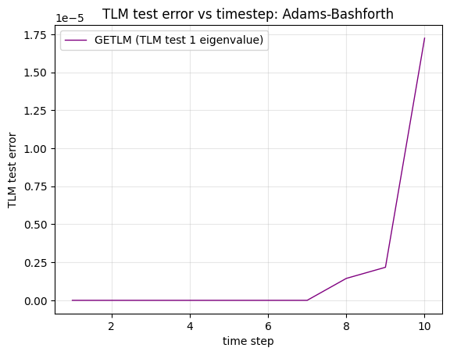(this is around 10^(-12) at 5 time steps)
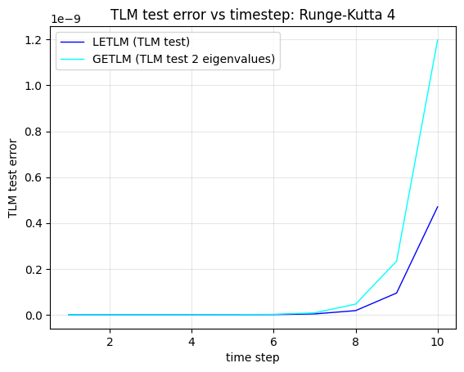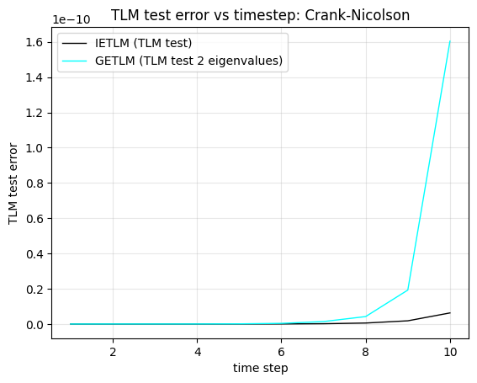
Setting the GETLM Stencil to be [(-2,-1,0,1), (-2,-1,0,1), (-2,-1,0,1)]. We get the following results:
